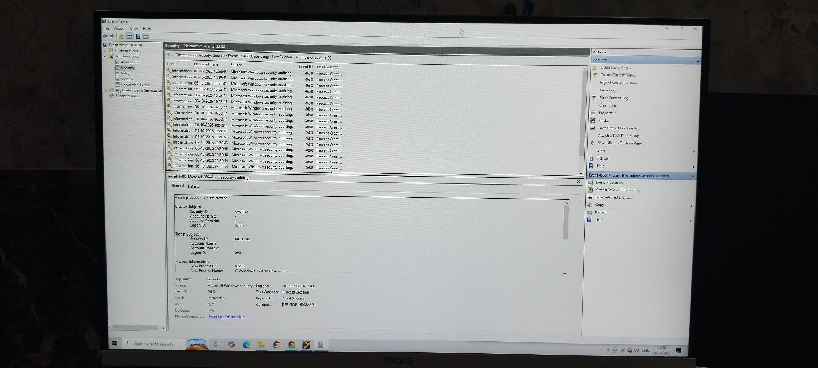

Figure 3 — Event ID 4688: Process Creation
I reviewed Event ID 4688 to identify a newly created process on the Windows system. From a SOC perspective, process creation events can help analysts determine what was executed and whether the process requires further investigation.

